**What is a UML Use Case Diagram?**

Use case diagrams model the functionality of a system using actors and use cases. Use cases are services or functions provided by the system to its users.

**Basic Use Case Diagram Symbols and Notations**

**System**

Draw your system's boundaries using a rectangle that contains use cases. Place actors outside the system's boundaries.

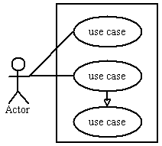

**Use Case**

Draw use cases using ovals. Label with ovals with verbs that represent the system's functions.

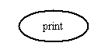

**Actors**

Actors are the users of a system. When one system is the actor of another system, label the actor system with the actor stereotype.

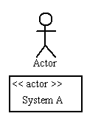

**Relationships**

Illustrate relationships between an actor and a use case with a simple line. For relationships among use cases, use arrows labeled either "uses" or "extends." A "uses" relationship indicates that one use case is needed by another in order to perform a task. An "extends" relationship indicates alternative options under a certain use case.

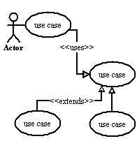



Fig: Admin Use Case diagram



Fig: User Use Case diagram